COIT20260 Cloud Computing and Internet of Things for Smart Applications

Assessment 1
Term T3 2025

Student ID: 12994001
Student Name: Jhoniex Mendros Gamayon
Campus: Melbourne
Tutor Name: Ali Shahidinejad
CQUniversity

Table of Contents

1. Introduction 4
2. Exploration of Cloud Services (PaaS + IaaS) 4
2.1 Amazon Web Services (AWS) – IaaS and PaaS 5
2.1.1 AWS IaaS Services 5
2.1.2 AWS PaaS Services 5
2.2 Microsoft Azure Cloud Services 6
2.2.1 Azure IaaS 6
2.2.2 Azure PaaS 7
3. Comparison of AWS vs Azure 7
3.1 Pricing 7
3.2 Scalability 8
3.3 Security 9
3.4 Performance 9
3.5 Support and Documentation 10
3.6 Strengths and Weaknesses Summary Table 10
3.7 Well-Supported Recommendations 10
4. Sample Application on AWS and Azure 11
4.1 Prototype Application on AWS 11
4.1.1 Creating the Compute Layer (EC2 Instance) 11
4.1.2 Creating the Database Layer (RDS Instance) 12
4.1.3 Building the Backend API (Node.js Server) 14
4.1.4 Building the Front-End Website 15
4.1.5 Security and Networking Configuration 17
4.1.6 Summary of AWS Prototype 17
4.2 Prototype Application on Azure 17
4.2.1 Creating the Compute Layer (Azure App Service) 17
4.2.2 Creating the Database Layer 19
4.2.3 Building the Backend API (Node.js on Azure App Service) 20
4.2.4 Security and Networking Configuration 22
4.2.5 Summary of Azure Prototype 22
5. Synthesis of Findings 23
6. Conclusion 23
7. References 24

Introduction
Cloud computing is now one of the most important technologies used by businesses today. It helps businesses to cut costs, scale easily and improve the security of the system, because instead of buying and managing their own servers, companies can use cloud services to store data, run applications, and build systems quickly and efficiently (Brown 2024). The three main service models are Infrastructure as a Service (IaaS), Platform as a Service (PaaS), and Software as a Service (SaaS). IaaS provides virtual machines and storage, PaaS gives developers ready-made environments to build and deploy applications, and SaaS delivers complete software over the internet (Amazon Web Services 2025).
Amazon Web Services and Microsoft Azure are two of the biggest cloud providers in the world. Both of them offer many services that can support organizations of different sizes (Griffiths 2025). Each platform brings its own strengths, tools, pricing and special features. Because of this, comparing the two platforms becomes important when a business wants to choose the best cloud solution for their needs.
In this report we will look at Amazon Web Services and Microsoft Azure to find which one is more suitable for TechGear Solutions. TechGear is an Australian smart home device company that is facing performance problems, issues with scaling, high maintenance costs and security concerns in their on premises systems. Since the company is growing fast and gets a lot of seasonal traffic, they need an infrastructure that can scale when needed, provide strong identity management and help them modernize their systems for the new customer order tracking application they want to build.

Exploration of Cloud Services (PaaS + IaaS)
In this section we will explore the key IaaS and PaaS services offered by AWS and Azure, focusing on how they directly support the operational challenges and modernization goals of TechGear Solutions. TechGear currently operates with an ageing LAMP web server, a MySQL customer database, and a manual Windows-based inventory system. To support their expected growth, they require cloud services that enable:
- Efficient scaling during peak sales periods
- Secure handling of customer and payment information
- Automated deployment and faster application development
- Cost optimization through pay-as-you-go models
- Support for a new lightweight web-based order-tracking application
The IaaS and PaaS services below represent the building blocks TechGear would rely on when transitioning from on-premises systems to a modern cloud infrastructure.

Amazon Web Services (AWS) – IaaS and PaaS

AWS IaaS Services
Service | Category | Description | Strengths | Relevance to TechGear
Amazon EC2 | Compute (IaaS) | Virtual machines with configurable CPU, memory, and OS. | Highly scalable, many instance families, pay-per-second billing. | Can replace TechGear’s LAMP server and auto-scale during Black Friday/EOFY spikes.
Amazon S3 | Storage (IaaS) | Highly durable object storage for files and media. | 11 9’s durability, low cost, integrates with CloudFront CDN. | Ideal for product images, logs, and offloading large static assets to speed up the website.
Amazon EBS | Block Storage | Persistent SSD/HDD storage volumes for EC2. | High performance, reliable, encrypted. | Suitable for hosting migrated MySQL workloads or application files.
Amazon VPC | Networking (IaaS) | Isolated cloud network with subnets, routing, firewalls. | Strong security, fine-grained control. | Supports PCI-DSS style segmentation for customer/payment data.
Amazon RDS | Managed Database | Fully managed relational DB (MySQL, MariaDB, PostgreSQL). | Automated backups, updates, scalability. | Direct replacement for TechGear’s on-prem MySQL database with minimal changes.

AWS PaaS Services
Service | Category | Description | Strengths | Relevance to TechGear
Elastic Beanstalk | PaaS | Automated deployment for web apps. | Manages servers, scaling, updates automatically. | Allows TechGear to deploy their new order-tracking app quickly with minimal admin work.
AWS Lambda | Serverless PaaS | Run code without provisioning servers. | Highly cost-effective; auto-scales instantly. | Can automate inventory updates or event-driven notifications.
API Gateway | PaaS | Secure, scalable API management. | Built-in authentication, throttling. | Suitable for exposing TechGear’s order-tracking API to customers securely.
AWS Fargate | Containers (PaaS) | Serverless container hosting. | No need to manage clusters or VMs. | Ideal for future microservices if TechGear modernises their backend.
AWS Amplify | PaaS | Hosting + backend tools for web/mobile apps. | Easy CI/CD, authentication, storage integration. | Could power TechGear’s customer-facing order-tracking frontend.

Microsoft Azure Cloud Services

Azure IaaS
Service | Category | Description | Strengths | Relevance to TechGear
Azure Virtual Machines | Compute (IaaS) | Windows/Linux VMs with flexible sizing. | Excellent for Windows integration. | Can migrate TechGear’s Windows inventory system into the cloud.
Azure Blob Storage | Storage (IaaS) | Scalable object storage for files and backups. | Tiered pricing, strong security. | Suitable for product images, logs, and media files.
Azure Disk Storage | Block Storage | SSD/HDD disks for VMs. | High performance, secure. | Supports database and transactional workloads.
Azure Virtual Network (VNet) | Networking | Private isolated cloud network. | Hybrid-cloud friendly. | Helps TechGear extend their existing on-prem Windows systems to Azure.
Azure SQL Managed Instance | Managed Database | Fully managed SQL Server compatible DB. | Easy migration for SQL workloads. | Useful if TechGear transitions from MySQL to Microsoft SQL technologies.

Azure PaaS
Service | Category | Description | Strengths | Relevance to TechGear
Azure App Service | PaaS | Fully managed hosting for web apps. | Auto-scaling, CI/CD, runtime management. | Ideal environment for TechGear’s planned order-tracking application.
Azure Functions | Serverless | Event-driven, pay-per-execution functions. | Tight Microsoft ecosystem integration. | Can automate inventory sync or send order status notifications.
Azure Kubernetes Service (AKS) | Containers | Managed Kubernetes environment. | Simplifies deployment of microservices. | Suitable if TechGear expands into microservices later.
Azure Logic Apps | Integration PaaS | Workflow automation. | No-code automation. | Can automate product updates or connect external suppliers.
Azure SQL Database | Managed DB | Fully managed relational database. | High performance, low admin workload. | Provides a modern alternative to TechGear’s existing database stack.

AWS and Azure both provide the best IaaS and PaaS services in terms of computing, storage, networking, and application development. AWS is known for its wide service variety and global presence, while Azure excels in enterprise and Microsoft-based environments. Both platforms offer powerful tools for deploying applications and managing cloud infrastructure.

Comparison of AWS vs Azure
When evaluating cloud providers for TechGear Solutions, the comparison must focus on how each platform addresses the company’s core challenges: slow performance during seasonal spikes, high infrastructure maintenance costs, weak security controls, manual workflows, and the need for a new customer order-tracking application. AWS and Azure are both capable platforms, but their strengths align differently with TechGear’s operational and strategic goals.
The following comparison examines pricing, scalability, security, performance, support, and how these factors impact TechGear’s cloud migration.

Pricing
Cost Component | AWS (Approx.) | Azure (Approx.) | Which Is Better for TechGear & Why
Compute (Linux VM / EC2)2 vCPU, 8 GB RAM | US$72.93 / month(m6a.large, on-demand) | US$75.64 / month(D2s v3, on-demand) | AWS – slightly cheaper and better optimised for Linux/LAMP workloads
Reserved / Committed Pricing (3-year) | ~US$70.08 / month | ~US$72.75 / month | AWS – marginally cheaper for long-term predictable workloads
Object Storage (Standard / Hot tier) | US$0.020 / GB / month (S3 Standard) | US$0.018 / GB / month (Blob Hot) | Azure – slightly cheaper for large static assets (images, logs)
Managed Relational Database (Entry tier) | ~US$12 / month (RDS MySQL small instance) | ~US$5 / month (Azure SQL Basic tier) | Azure – cheaper at very small scale, but limited performance
Scaling Costs | Automatic scaling, pay only for usage | Automatic scaling, pay only for usage | Tie – both scale well, cost depends on traffic patterns

TechGear operates a Linux-based LAMP website and a MySQL database, which makes AWS more cost-effective for their primary workloads due to lower compute pricing and more flexible discount mechanisms (Kroeze, 2025). Azure becomes more attractive only if TechGear intends to migrate their Windows-based inventory system, as Azure typically provides better pricing for Microsoft-centric workloads (Kroeze, 2025).

Scalability
AWS
- Industry leader in auto-scaling maturity.
- Auto Scaling Groups, S3 scale-out, and Lambda provide near-instant elasticity.
- Designed for high-traffic global retail patterns.
Azure
- Strong scalability for enterprise environments.
- VM Scale Sets and App Service auto-scaling work well but tend to integrate best with Microsoft-centered ecosystems.
Relevance to TechGear
TechGear experiences significant seasonal demand spikes (Black Friday, EOFY sales).
AWS’s auto-scaling reliability and global retail optimisation make it exceptionally strong for this scenario. The most advantageous for the business is AWS.

Security
AWS
- Provides granular identity control using IAM.
- Advanced cloud-native security tools: GuardDuty, WAF, Shield which is specifically designed for internet-facing workloads (Gaurav 2025).
- Ideal for modern API-driven architectures.
Azure
- Security is tightly integrated with Microsoft’s enterprise ecosystem.
- Azure Active Directory offers seamless identity management for Windows-based organisations.
- Strong tools such as Azure Security Center and Sentinel.
Relevance to TechGear
TechGear handles payment data, requiring strong compliance controls. AWS’s security model is excellent for public-facing e-commerce platforms, while Azure is superior for organisations already fully embedded in Microsoft services. Since TechGear’s core systems (LAMP + MySQL) are not Microsoft-based, AWS’s cloud-native security tools better match their current architecture.
Azure becomes relevant once they migrate their Windows inventory system which in conclusion, gives edge to AWS

Performance
AWS
- Broadest global infrastructure footprint.
- Highly optimised networks for Linux-based workloads, containers, and web-scale applications.
Azure
- Strong performance for Windows workloads and enterprise database solutions.
- Excellent SQL Server integration and hybrid cloud networking.
Relevance to TechGear
TechGear’s performance bottlenecks occur during high traffic on their e-commerce site. AWS provides superior global routing and caching options (CloudFront + S3), improving load times and serving static assets efficiently.
Azure would only outperform AWS if TechGear migrated everything into a Microsoft ecosystem which is not currently the case.

Support and Documentation
AWS
- Comprehensive, developer-focused documentation suited for engineering teams.
- Extensive global community, tutorials, and certification pathways.
Azure
- More beginner-friendly documentation.
- Strong enterprise support and integration with Microsoft 365 environments.
Relevance to TechGear
TechGear’s upcoming order-tracking application requires web and API development. AWS’s developer-centric ecosystem provides a smoother learning environment for building modern, scalable web apps.

Strengths and Weaknesses Summary Table
Provider | Strengths (for TechGear) | Weaknesses (for TechGear)
AWS | Best scalability for retail spikes, strong security for public websites, cost-effective for LAMP/MySQL, excellent documentation, global performance | Pricing complexity, steep learning curve for beginners
Azure | Great for Windows systems, strong identity management, simplified PaaS deployment, good hybrid cloud tools | Less optimized for Linux-heavy workloads, fewer instance options, weaker global retail performance

Well-Supported Recommendations
After comparing AWS and Azure for the needs of TechGear Solutions, AWS is the better choice for the company at this time. TechGear uses a LAMP website and a MySQL database, and both of these works very well on AWS. AWS can also handle sudden increases in website traffic during busy sales events, which is important because TechGear often experiences slow performance during peak times. AWS offers strong security tools that help protect customer and payment information, which is one of TechGear’s biggest concerns. AWS services like CloudFront and S3 can also make the website load faster for customers, solving the slow page issues the business currently faces.
Azure is still a good platform, but it is more useful for companies that use many Microsoft systems. TechGear only uses a Windows system for inventory, and it is not their main system now. Because of this, Azure does not provide as many immediate benefits compared to AWS.
Overall, AWS is the best choice for TechGear right now because it improves performance, security, cost control, and supports the new order tracking application they plan to build. Azure may become more useful in the future if TechGear decides to move more of their Windows systems into the cloud.

Sample Application on AWS and Azure
This section shows how simple prototype applications were created on both AWS and Azure to help TechGear Solutions understand how each cloud platform works. The purpose of these prototypes is not to build a full system, but to show how the company can run a basic website and a small backend application in the cloud. This also helps TechGear compare how easy each platform is to use, how applications are deployed, and how the cloud can improve their current problems with slow performance, high maintenance, and limited scalability.

Prototype Application on AWS

Creating the Compute Layer (EC2 Instance)
The application began by launching an EC2 instance using Amazon Linux, t2.micro, and a newly created security group allowing ports 22 (SSH), 80 (HTTP), and 3000 (API). Apache HTTP Server was installed and enabled, allowing the instance to host a basic webpage.
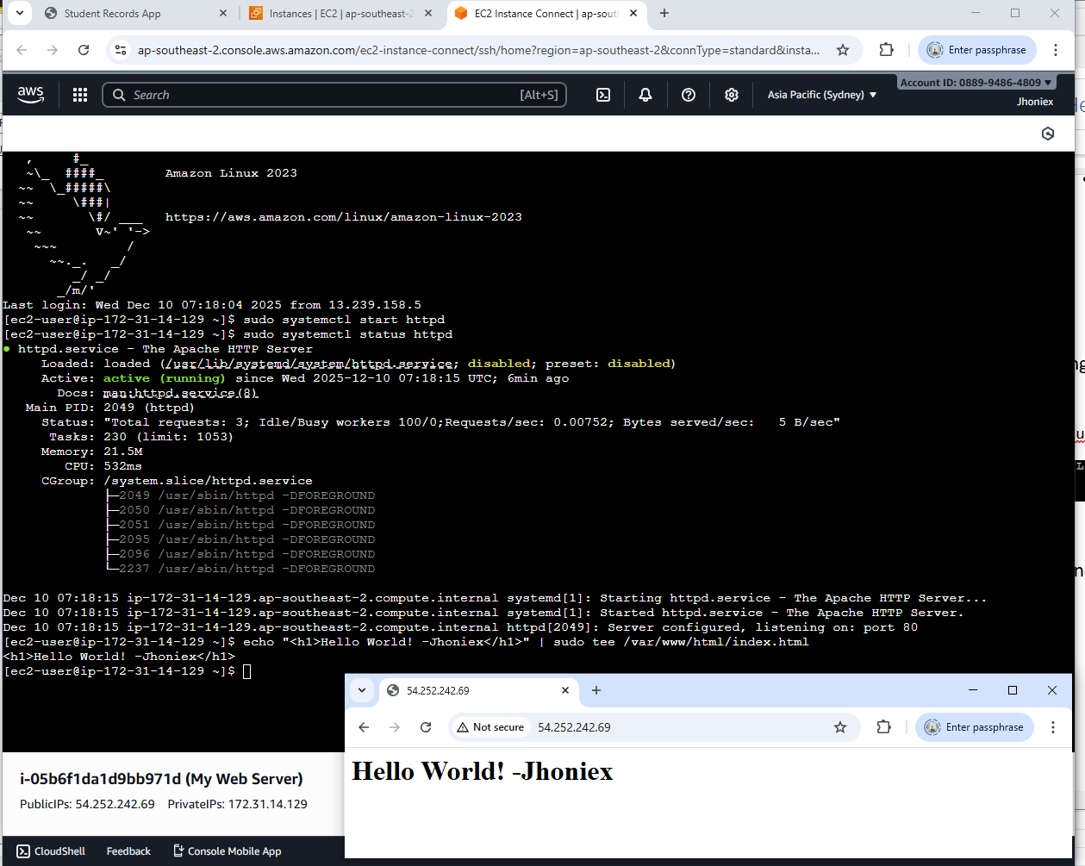
In this instance, I deployed my first public “Hello World” website using AWS, which can be accessed through: http://54.252.242.69. Though this website is no longer available because I stopped the instance to prevent further charges.

Creating the Database Layer (RDS Instance)
A MariaDB database was created using Amazon RDS. This represents TechGear’s current MySQL customer database moving into the cloud. RDS handles backups, updates, monitoring, and storage automatically, which reduces the manual work TechGear’s staff currently face.
The database was placed in a private subnet to improve security and protect customer information. EC2 communicated with the RDS instance through a secure connection.
I also created a MariaDB database using both Amazon Aurora and the RDS service and connected it to my previously made EC2 instance.
In my EC2 terminal I run the following command to install MariaDB:
- sudo dnf install -y mariadb105
- mysql -h database-1.cjy6eys0ip8k.ap-southeast-2.rds.amazonaws.com -P 3306 -u admin -p
To match the business scenario, we created a new database called TechGear inside the EC2 instance. This database was used to simulate how TechGear Solutions would store customer information in the cloud. The database was created using the command CREATE DATABASE TechGear; and then selected with USE TechGear;. Inside the database, we created a table named customer_records which holds basic customer details such as name, address, city, state, email, and phone number.
The table was created using the following SQL command:
- CREATE TABLE customer_records ( id INT AUTO_INCREMENT PRIMARY KEY, name VARCHAR(100) NOT NULL, address VARCHAR(255), city VARCHAR(100), state VARCHAR(100), email VARCHAR(150) UNIQUE, phone VARCHAR(20) );
This simple structure allowed us to test how a real customer database would run on AWS and how it could support TechGear’s planned order tracking system.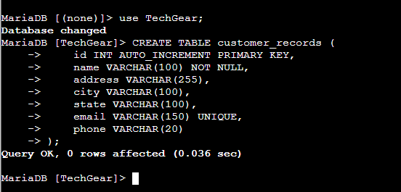
After creating the customer_records table, we added sample customer data to simulate how TechGear would store real customer information in the cloud. This helped us test the database connection, API functions, and front end operations. We inserted ten sample customers using an INSERT INTO SQL command, each with details such as name, address, city, state, email, and phone number. Once the data was inserted, we confirmed that it was successfully stored by running a SELECT * FROM customer_records; query, which displayed all customer records in the table. This showed that the database was working correctly and that the application could read the customer information without errors.
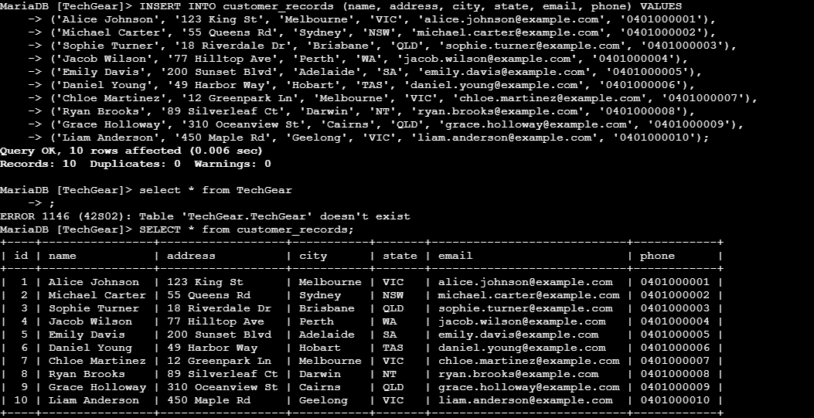

Building the Backend API (Node.js Server)
In week 4 Tutorial, the Node.js backend was developed on the EC2 instance. Node.js was installed using the following command:
- curl -fsSL https://rpm.nodesource.com/setup_20.x | sudo bash –
- sudo dnf install -y nodejs
- Created project folder and installed required modules (express, cors, mysql2, body-parser).
- mkdir customer-api && cd customer-api
- npm init -y
- npm install express cors mysql2 body-parser

- The backend API (apiServer.js) was implemented using Express, with routes for:
- Adding new student records
- Retrieving all records
- Deleting a student by ID
- Using the command nano apiServer.js to open the js file and edit it. I used the provided sample code during the tutorial.
- Developed a REST API (apiServer.js) with routes to:
- Used the command “nohup node apiServer.js > output.log 2>&1 &” to start the server.
- Insert a customer record sample data using the API “.
- Delete a customer record based on its ID using the api “curl -X DELETE http://localhost:3000/customers/1”
Sample API operations, including inserting and deleting records using curl, confirmed correct functionality.

Building the Front-End Website
Still in Week 4 Tutorial, the front-end was developed inside /var/www/html/index.html using HTML, CSS, jQuery, and AJAX calls that interacted with the Node.js backend.
The website allowed users to:
- Insert customer records
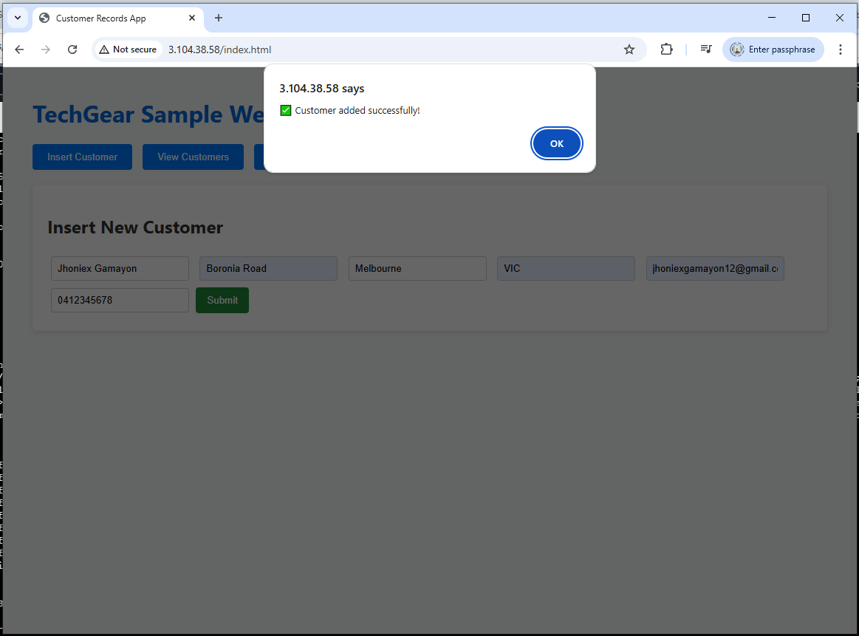
- View all stored records
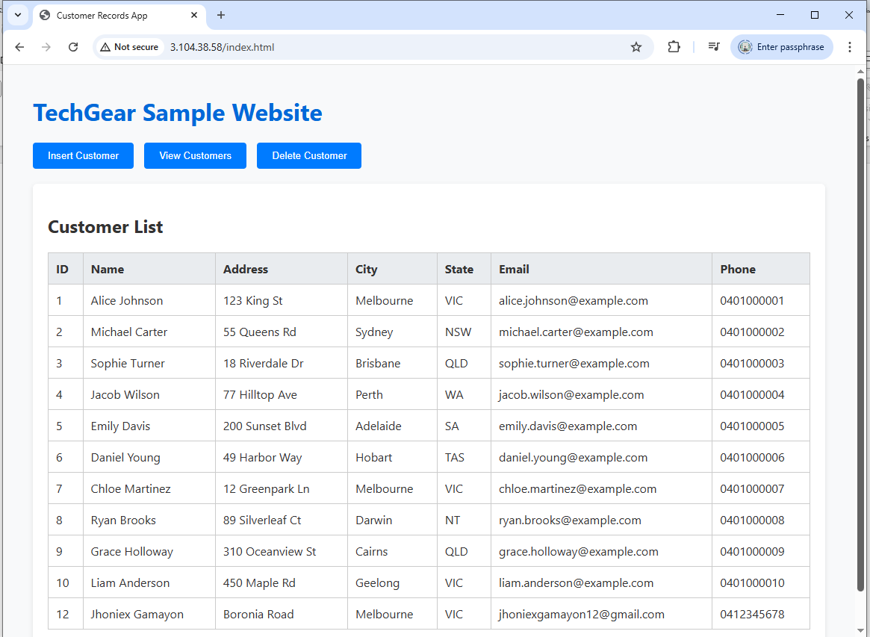
- Delete a customer by ID
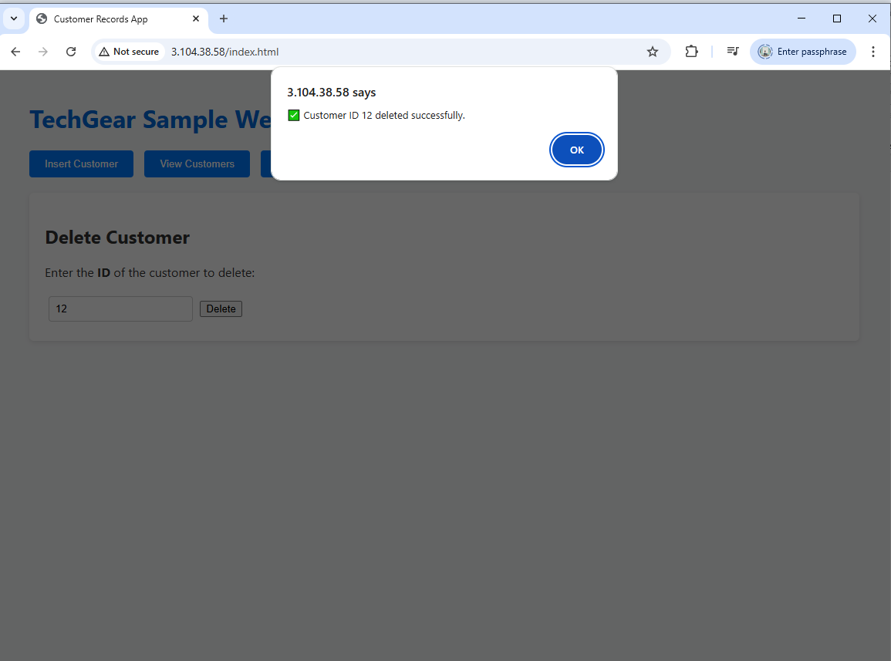
Testing confirmed that the EC2 instance communicated correctly with RDS through port 3306, and that the API responded as expected. All interactions were routed through the Node.js API hosted on port 3000. Successful AJAX responses verified proper communication between EC2 (frontend), EC2 (backend), and RDS (database).

Security and Networking Configuration
The EC2 instance was placed in a public subnet so it can be reached through the internet using the Internet Gateway. The RDS database was placed in private subnets where no one from outside can access it directly. This helps protect the customer records inside the database. The security groups only allowed the ports that we really needed which are port 22 for SSH, port 80 for the website and port 3000 for the backend API. The outbound rules also let the EC2 instance connect to the RDS database using MySQL.
This setup follows the common best practice for a secure three layer architecture. It shows how TechGear can protect their system more compared to their old on premises setup which does not have strong separation of systems. It also shows how AWS makes it easier to control traffic and keep the database safe from the public internet.

Summary of AWS Prototype
The AWS prototype successfully demonstrated the full lifecycle of deploying a cloud-hosted dynamic web application. Key achievements include:
- EC2 hosting both the frontend website and Node.js backend API
- RDS providing a reliable, managed relational database
- Correct network segmentation using public and private subnets
- Secure communication between EC2 and RDS
- Implementation of full CRUD functionality via API routes
- A working dynamic customer records website using AWS services

This demonstrates a strong practical understanding of AWS architecture, combining IaaS (EC2, VPC, RDS networking) and PaaS-style deployment components (Node.js application runtime on EC2). The prototype reflects real-world cloud application design and aligns directly with Week 2–5 tutorial activities.

Prototype Application on Azure
To compare AWS and Azure fairly, a second prototype application was deployed on Microsoft Azure. Unlike AWS, where more manual setup was required, Azure provides a higher-level PaaS environment through Azure App Service and MySQL Database, allowing applications to be deployed faster with less operational overhead. This prototype demonstrates how TechGear Solutions could host their planned order-tracking application or migrate components of their Windows-based inventory system into Azure’s ecosystem, addressing their business needs for modernisation, reduced maintenance and easier scalability.

Creating the Compute Layer (Azure App Service)
The application was deployed using Azure App Service, a fully managed PaaS environment that automatically handles load balancing, updates, runtime management, and auto-scaling.
Steps performed:
- Navigated to the Azure Portal and created a new Web App.
- Selected:
- Runtime stack: Node.js 24 LTS
- Hosting Plan: Basic B1 (suitable for testing and small production workloads)
- Region: Australia East (to ensure low latency for TechGear’s customers)
- Azure automatically created the hosting environment, file structure, and continuous deployment pipeline.
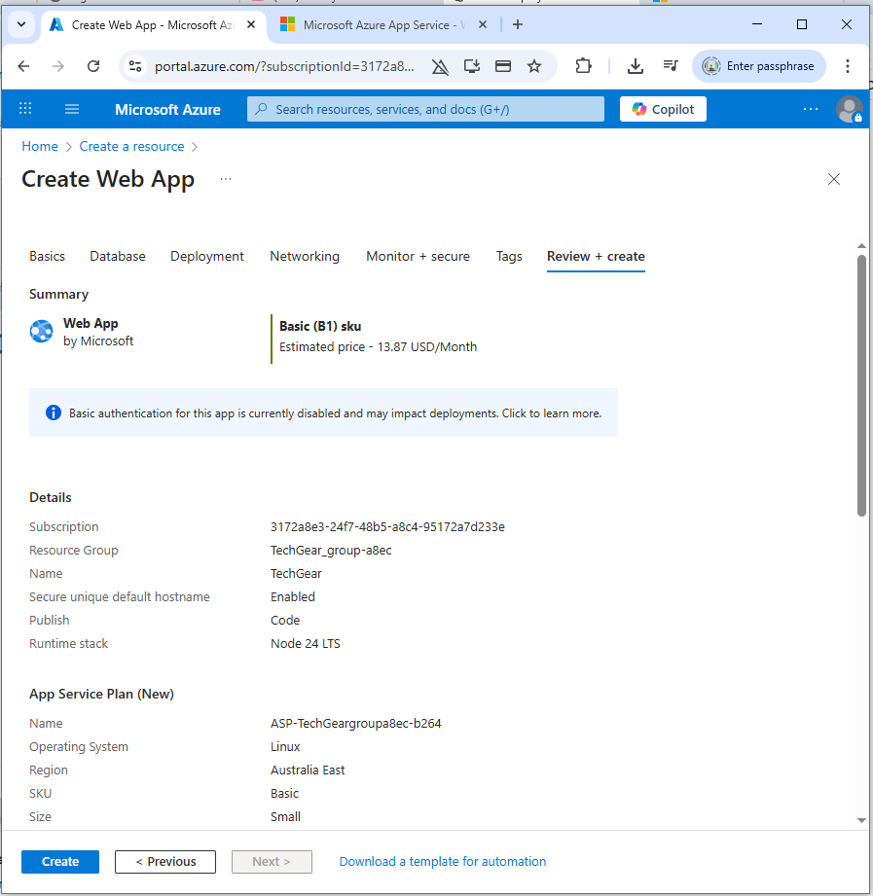
Deployment Process:
- Used the “Deployment Center” within Azure App Service.
- Connected the Web App to a GitHub repository containing the same Node.js API used on AWS.
- Azure built, deployed, and started the application automatically.
Outcome:
The Node.js backend API was live without needing to configure virtual machines, security groups, or operating systems. This highlights why Azure App Service can significantly reduce operational effort for TechGear’s future applications.
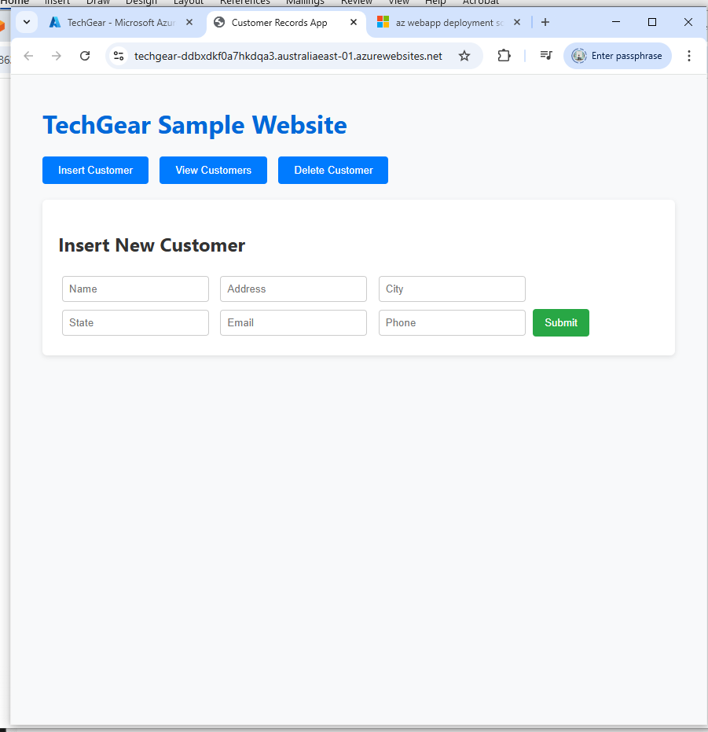

Creating the Database Layer
To replicate the functionality of the customer_records table from AWS, a relational database was created using MySQL Database, a fully managed cloud database service.
Database Setup:
  - Created an MySQL Server instance and enabled transparent data encryption.
  - Created a new SQL Database named TechGear.
  - Configured firewall rules to allow access only from the App Service environment.
  - Connected using Azure Cloud Shell
Table Creation:
A similar customer table was created to maintain parity with the AWS prototype:
CREATE TABLE customer_records (
id INT IDENTITY(1,1) PRIMARY KEY,
name VARCHAR(100) NOT NULL,
address VARCHAR(255),
city VARCHAR(100),
state VARCHAR(100),
email VARCHAR(150) UNIQUE,
phone VARCHAR(20)
);
Sample data insertion:
Ten test customer records were inserted using INSERT INTO statements to populate sample data as same with what we did in the AWS sample.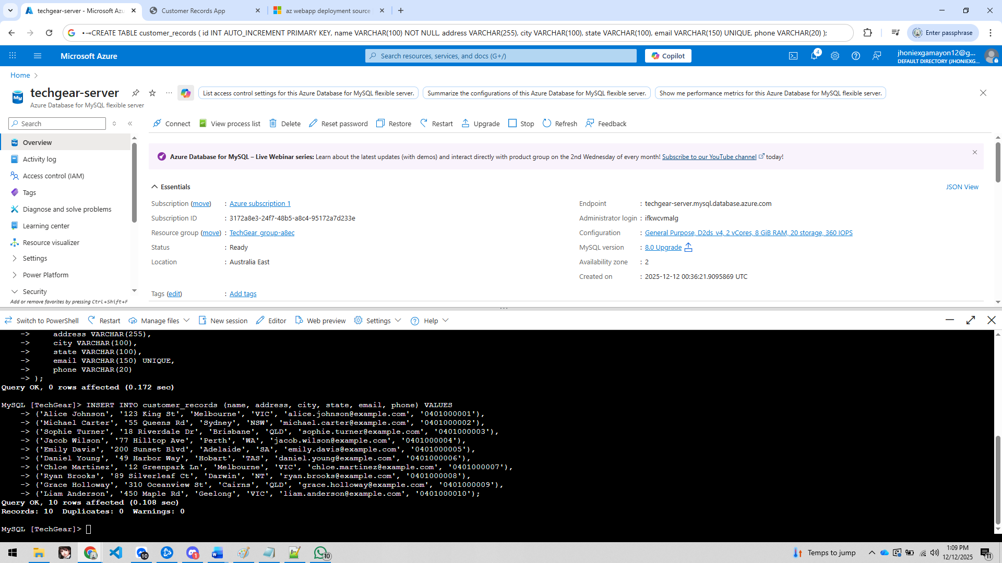

Building the Backend API (Node.js on Azure App Service)
The same Node.js Express API used in the AWS prototype was reused to ensure a fair comparison. The API included routes for:
- Inserting new customer records
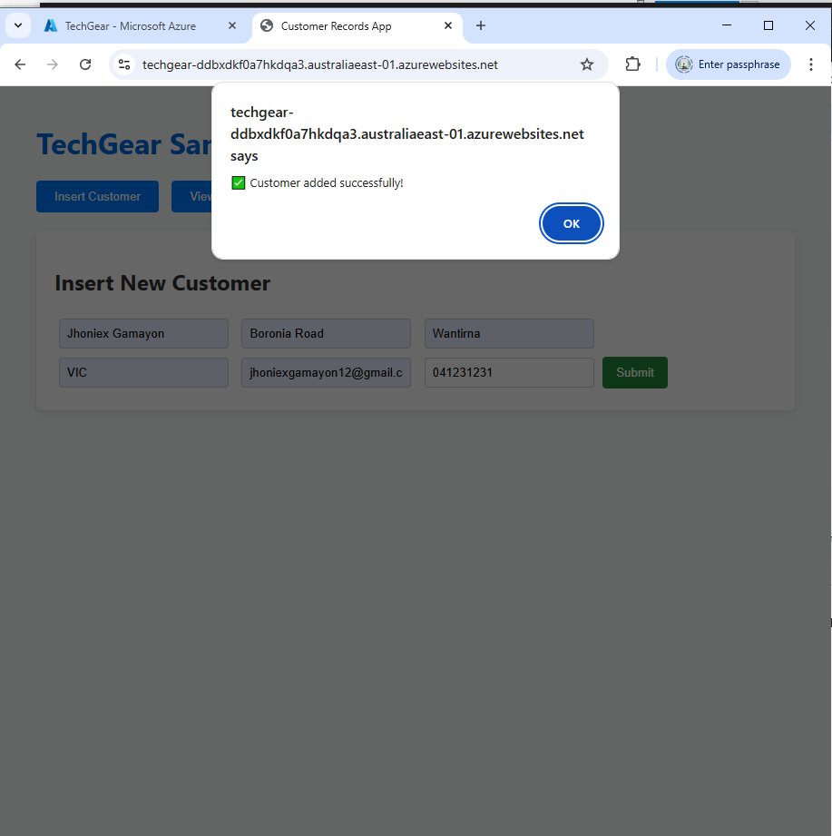
- Retrieving all customer records
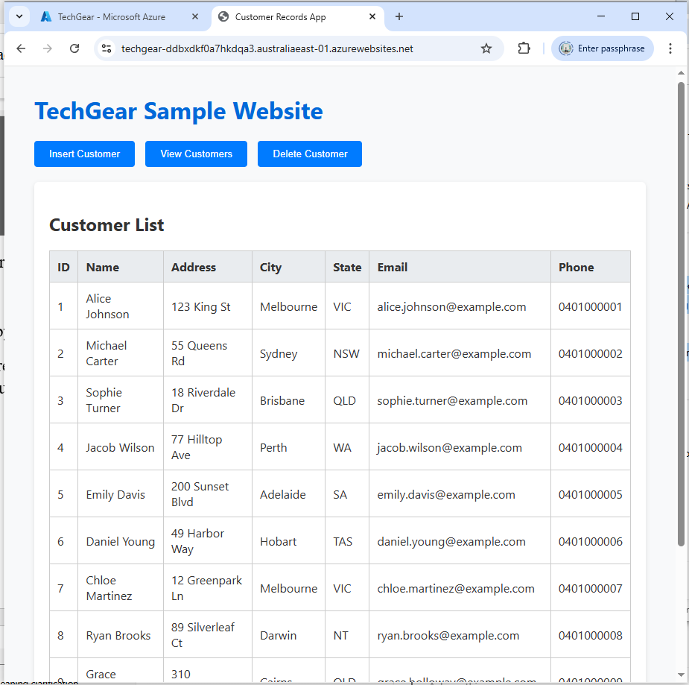
- Deleting a customer record by ID
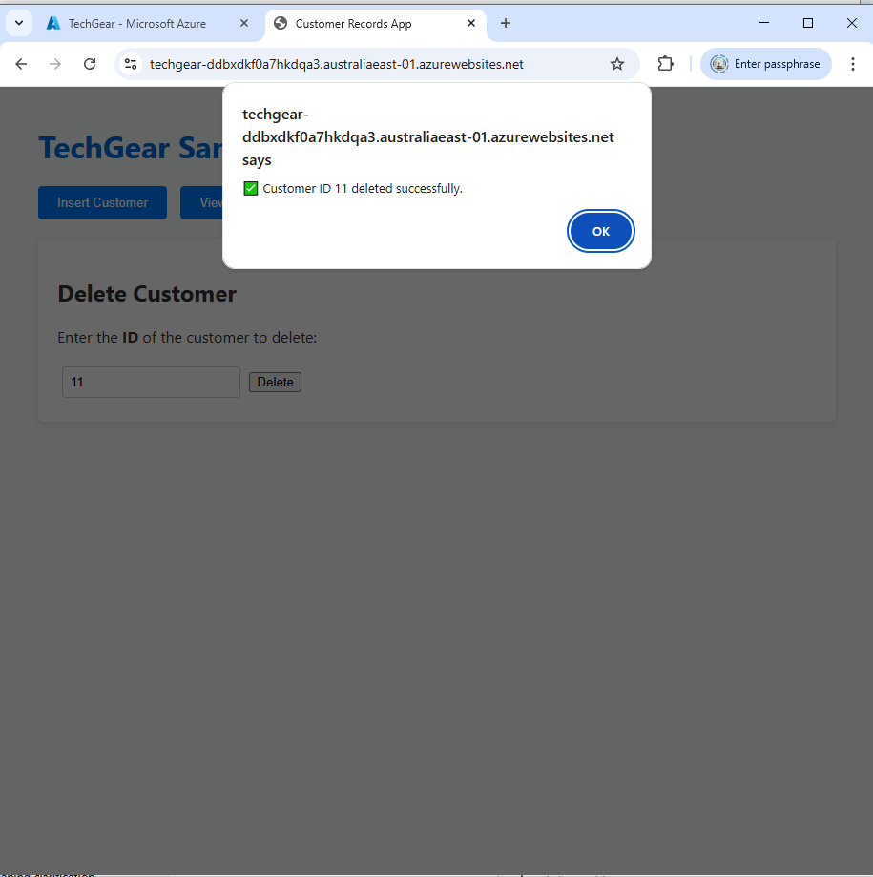
The website has been deployed using Azure Deployment Center, which can be accessed through https://techgear-ddbxdkf0a7hkdqa3.australiaeast-01.azurewebsites.net/ . It is connected to a GitHub repository containing the application source code. Once linked, Azure automatically:
- Pulled the source code
- Installed dependencies
- Built the application
- Started the Node.js service
We didn’t perform any manual SSH access, package installation, or process management (such as nohup) because it is not required. This highlights Azure’s advantage in reducing deployment complexity. The backend API became publicly accessible through the App Service URL, with HTTPS enabled by default.

Security and Networking Configuration
Azure App Service includes built in security features. HTTPS was enabled automatically. The MySQL database was not accessible from the public internet. Access was restricted using firewall rules that only allowed traffic from the App Service. This setup improves security compared to TechGear’s on premises environment. Customer data is protected without complex manual configuration.

Summary of Azure Prototype
The Azure prototype successfully demonstrated how a cloud-based application can be deployed using managed services. Key results include:
- The backend API was hosted using Azure App Service
- The MySQL database was hosted using Azure Database for MySQL
- Deployment was automated using GitHub integration
- Security and backups were managed by Azure
- Customer records could be added, viewed, and deleted successfully
This prototype shows how Azure reduces system maintenance and simplifies application deployment.

Synthesis of Findings
The sample applications that we created on AWS and Azure helped us understand how each cloud platform works for TechGear Solutions. When we built the application on AWS, we needed to set up many things by ourselves like the EC2 server, the RDS database, the network settings and also the Node.js backend. Doing all these steps showed us how the cloud works from the beginning and how AWS gives a lot more control to the user. This is helpful for TechGear because they want better performance and better security for their website, and also they want to build the new order tracking system for their customers.
Azure was a bit easier because we did not need to manage many server settings. When we used Azure App Service, most of the hard work was already done by Azure. It handled the updates, scaling and other settings by itself. This makes Azure a good choice for companies who do not want to deal with too much technical work and just want to deploy their app fast.
Both platforms were able to run the application without problem, but they give different benefits. AWS gives more control and is better for heavy traffic, especially when TechGear has busy sale events. Azure gives a smoother experience and is easier to use for people who want simple deployment. These results showed that both platforms are strong but in different ways, and this helps TechGear decide which cloud service fits their needs the most.

Conclusion
This report compared AWS and Azure to see which one is better for TechGear Solutions. Both cloud providers have strong services and both were able to run the sample application we created. AWS gives more control over the system and can handle busy times very well. Azure is easier to use and needs less server work from the user.
After looking at everything, AWS is the better option for TechGear right now. Their website uses a LAMP system and a MySQL database, and these types of systems usually work better on AWS. AWS also provides strong security and better performance, which TechGear really needs because of the slow speeds and high website traffic they get during sale events. This also helps them build the new customer order tracking system they want.
Azure can still be useful later if TechGear decides to move more of their Windows systems into the cloud. But for now, AWS fits their needs more closely. It helps improve website speed, protect customer information and support future development. The hands-on work in this assessment shows that cloud computing can really help TechGear grow and improve their systems.

References
Amazon Web Services 2025, Types of cloud computing, viewed 1 December 2025, https://aws.amazon.com/types-of-cloud-computing/.
Brown, R 2024, Cloud computing technology to help your business, viewed 1 December 2025, https://tct.com.au/blog/cloud-computing-technology-to-help-your-business/.
Griffiths, C 2025, The latest cloud computing statistics, viewed 1 December 2025, https://aag-it.com/the-latest-cloud-computing-statistics.
Gaurav, S 2025, ‘AWS WAF, Shield, and GuardDuty: Security at Scale’, Dev Community, viewed 12 December 2025, https://dev.to/imsushant12/aws-waf-shield-and-guardduty-security-at-scale-41p7.
Kroeze, N 2025, ‘Azure vs AWS pricing’, Intercept Cloud, viewed 12 December 2025, https://intercept.cloud/en-gb/blogs/azure-vs-aws-pricing.

